Data & Cloud Skill Up and Exam Ready Workshop 70-477: Perform Cloud Data Science with Azure Machine Learning

**Day 1** - Month Day, 2018

Floor: xxx Room xxxx

Wifi: MSFTGUEST

WiFi Password: [EnterPasswordHere]

|  |  |  |
| --- | --- | --- |
| Time | Speaker | Topic |
| 8:30 AM |  | Registration and Breakfast |
| 9:00 AM |  | Welcome remarks |
| 9:15 AM |  | Logistics; Agenda Overview |
| 9:30 AM |  | Prepare Data for Analysis in Azure Machine Learning and Export from Azure Machine Learning |
| 11:30 AM | Labs/Lunch & Networking | |
| 1:00 PM |  | Develop Machine Learning Models |
| 3:30 PM | Hands-On Labs | |
| 5:00 PM | Optional Cocktail Hour??? [TBD] | |

**Evaluation Link**  {TBD]

**Content:** [**https://github.com/guruskill/70-477**](https://github.com/guruskill/70-477)

Data & Cloud Skill Up and Exam Ready Workshop 70-477: Perform Cloud Data Science with Azure Machine Learning

**Day 2** - Month Day, 2018

Floor: xxx Room xxxx

Wifi: MSFTGUEST

WiFi Password: [EnterPasswordHere]

|  |  |  |
| --- | --- | --- |
| Time | Speaker | Topic |
| 8:30 AM |  | Registration and breakfast |
| 9:00 AM |  | Operationalize and Manage Azure Machine Learning Services |
| 12:00 PM | Labs/Lunch & Networking | |
| 1:00 PM |  | Use Other Services for Machine Learning |
| 2:30 PM | Break- 15 minutes | |
| 2:45 PM |  | Making ML Real for You |
| 3:45 PM | Hands-On Labs | |
| 5:00 PM | Cocktail hour ???? [TBD] | |

**Evaluation Link** 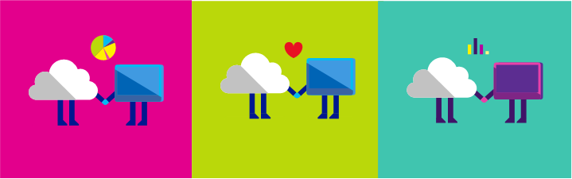 [TBD]

**Content:** [**https://github.com/guruskill/70-477**](https://github.com/guruskill/70-477)